SIMATS ENGINEERING
SAVEETHA INSTITUTE OF MEDICAL AND TECHNICAL SCIENCES
CHENNAI – 602105
Department of Computer Science and Engineering
ASSESSMENT TOOL 2 – DEIGN AND CONNECTIVITY
Course Code: | DSA05 | Course Title: | Query Processing for Data Science With Real Time Applications
CO Assessed: | CO2 | Assessment: | Tool 1 – DEIGN AND CONNECTIVITY
Weightage: |  | Total Marks: | 40 Marks
CO2 Statement: Use Python basics and SQL libraries to connect to databases SQLite, MySQL, PostgreSQL and perform CRUD operations like Create, Read, Update, Delete. (BTL6)
Student Name: | SIDDARTH P | Reg. No.: | 192324264
Section / Batch: | 2023 | Date of Submission:
Faculty In-charge: | Dr. B.SHYAMALA GOWRI | Project Mode: | Individual Submission

Code of Conduct
I SIDDARTH P / 192324264 (Name / Reg No) certify that this submission is my original work and that I have adhered to all guidelines specified for this assessment. I understand that any violation of academic integrity rules will result in disciplinary action.
Signature: SIDDARTH P

Requirement  Analysis  (5 Marks) | ER Diagram  Design  (10 Marks) | Table Design &  Normalization  (5 Marks) | Database  Connectivity  using Python  (20 Marks) | CRUD  Operations  (5 Marks) | Total  (35 Marks)

Scenario 2
1. Requirement Analysis
- Store patient details, doctor information, appointments, treatment, lab tests and payments centrally.
- A patient can consult multiple doctors; a doctor can consult multiple patients (many-to-many via Appointment).
- Each appointment leads to a treatment record with diagnosis and prescribed medicines.
- Lab tests and payments must be traceable back to the patient and appointment.
- System must support fast retrieval of patient history and reports on disease trends & doctor workload.
2. ER Diagram
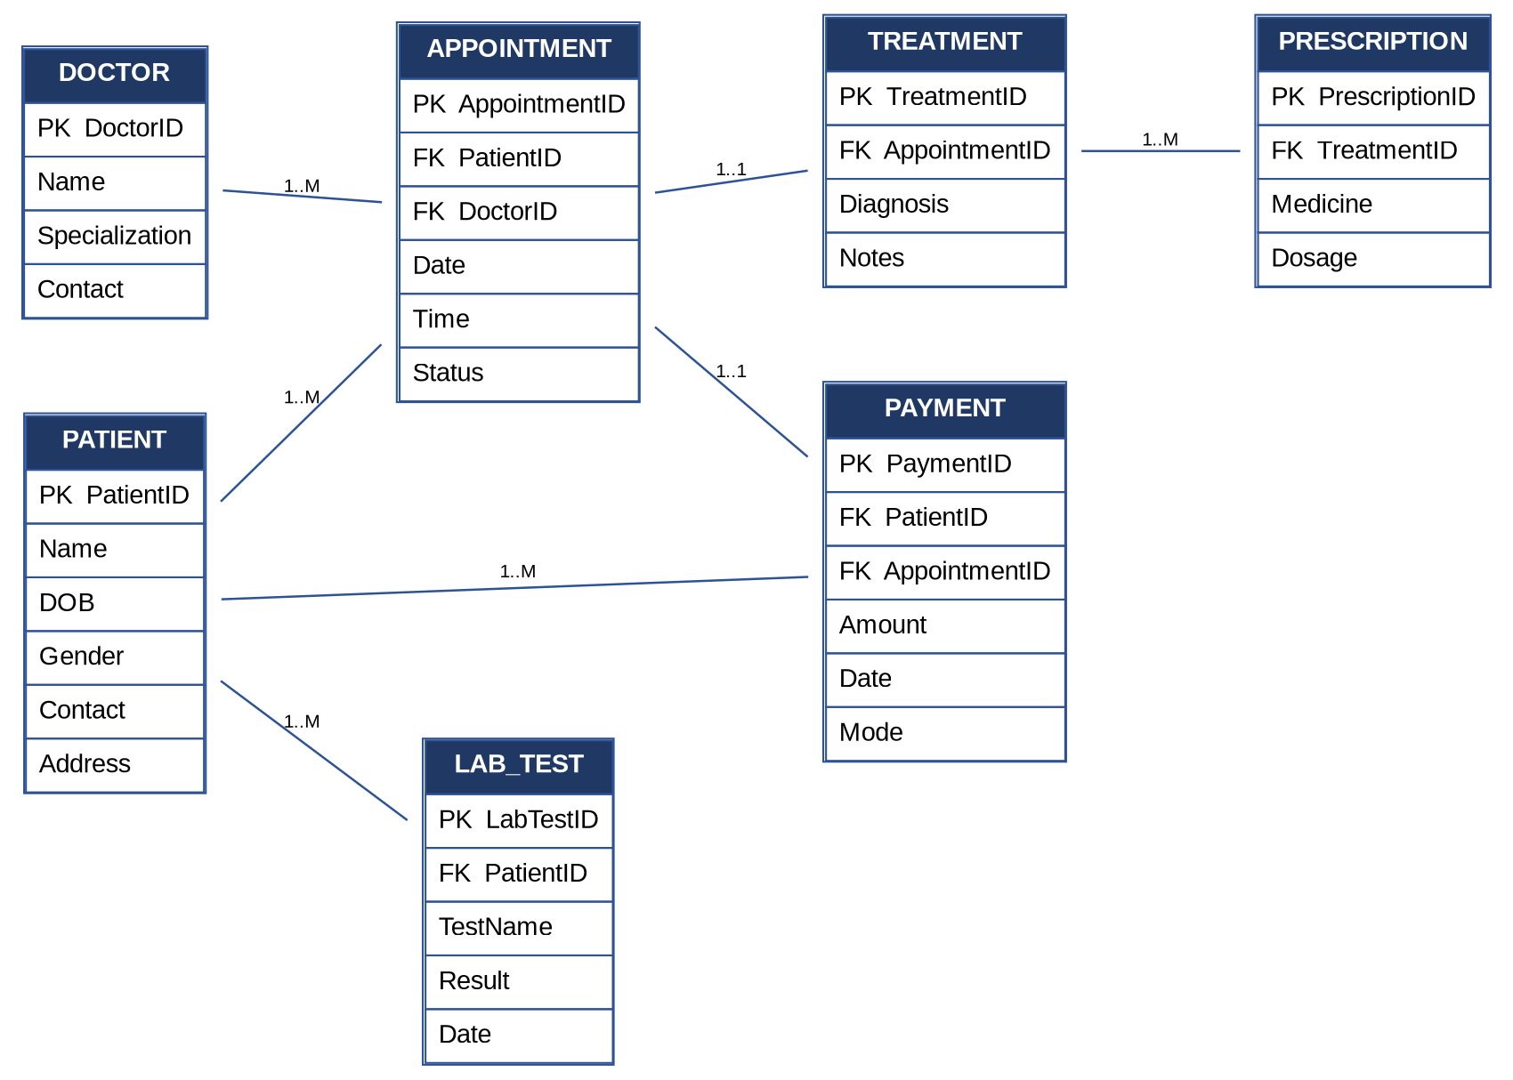
3. Database Connectivity using Python
import sqlite3

conn = sqlite3.connect("hospital.db")
cursor = conn.cursor()

cursor.execute("""
CREATE TABLE IF NOT EXISTS Doctor (
DoctorID INTEGER PRIMARY KEY,
Name TEXT NOT NULL,
Specialization TEXT,
Contact TEXT
)
""")

cursor.execute("""
CREATE TABLE IF NOT EXISTS Patient (
PatientID INTEGER PRIMARY KEY,
Name TEXT NOT NULL,
DOB TEXT,
Gender TEXT,
Contact TEXT,
Address TEXT
)
""")

cursor.execute("""
CREATE TABLE IF NOT EXISTS Appointment (
AppointmentID INTEGER PRIMARY KEY,
PatientID INTEGER,
DoctorID INTEGER,
Date TEXT,
Time TEXT,
Status TEXT,
FOREIGN KEY (PatientID) REFERENCES Patient(PatientID),
FOREIGN KEY (DoctorID) REFERENCES Doctor(DoctorID)
)
""")

cursor.execute("""
CREATE TABLE IF NOT EXISTS Payment (
PaymentID INTEGER PRIMARY KEY,
PatientID INTEGER,
AppointmentID INTEGER,
Amount REAL,
Date TEXT,
Mode TEXT,
FOREIGN KEY (PatientID) REFERENCES Patient(PatientID),
FOREIGN KEY (AppointmentID) REFERENCES Appointment(AppointmentID)
)
""")

conn.commit()

4. CRUD Operations
cursor.execute("INSERT INTO Doctor VALUES (101, 'Dr. Arvind Kumar', 'Cardiology', '9876543210')")
cursor.execute("INSERT INTO Doctor VALUES (102, 'Dr. Meena Rao', 'Orthopedics', '9876543211')")

cursor.execute("INSERT INTO Patient VALUES (1, 'Ramesh Babu', '1990-05-12', 'Male', '9123456780', 'Chennai')")
cursor.execute("INSERT INTO Patient VALUES (2, 'Lakshmi Priya', '1985-11-23', 'Female', '9123456781', 'Coimbatore')")

cursor.execute("INSERT INTO Appointment VALUES (5001, 1, 101, '2026-08-01', '10:30', 'Completed')")
cursor.execute("INSERT INTO Appointment VALUES (5002, 2, 102, '2026-08-02', '11:00', 'Scheduled')")

cursor.execute("INSERT INTO Payment VALUES (9001, 1, 5001, 1500.00, '2026-08-01', 'Card')")

conn.commit()
print("Tables created and sample records inserted successfully.")

print("\n--- READ: All Patients ---")
cursor.execute("SELECT * FROM Patient")
for row in cursor.fetchall():
print(row)

print("\n--- READ: All Appointments with Doctor and Patient Names ---")
cursor.execute("""
SELECT A.AppointmentID, P.Name, D.Name, A.Date, A.Status
FROM Appointment A
JOIN Patient P ON A.PatientID = P.PatientID
JOIN Doctor D ON A.DoctorID = D.DoctorID
""")
for row in cursor.fetchall():
print(row)

cursor.execute("UPDATE Appointment SET Status = 'Completed' WHERE AppointmentID = 5002")
conn.commit()
print("\n--- UPDATE: Appointment 5002 status updated to Completed ---")

print("\n--- READ: Verify Update ---")
cursor.execute("SELECT AppointmentID, Status FROM Appointment WHERE AppointmentID = 5002")
for row in cursor.fetchall():
print(row)

cursor.execute("DELETE FROM Payment WHERE PaymentID = 9001")
conn.commit()
print("\n--- DELETE: Payment record 9001 removed ---")

print("\n--- READ: Remaining Payments ---")
cursor.execute("SELECT * FROM Payment")
rows = cursor.fetchall()
if not rows:
print("No payment records found.")
else:
for row in rows:
print(row)

conn.close()
print("\nDatabase connection closed.")

5. Terminal Output
PS C:\Users\Siddarth\QueryProcessing> python scenario2.py
Tables created and sample records inserted successfully.

--- READ: All Patients ---
(1, 'Ramesh Babu', '1990-05-12', 'Male', '9123456780', 'Chennai')
(2, 'Lakshmi Priya', '1985-11-23', 'Female', '9123456781', 'Coimbatore')

--- READ: All Appointments with Doctor and Patient Names ---
(5001, 'Ramesh Babu', 'Dr. Arvind Kumar', '2026-08-01', 'Completed')
(5002, 'Lakshmi Priya', 'Dr. Meena Rao', '2026-08-02', 'Scheduled')

--- UPDATE: Appointment 5002 status updated to Completed ---

--- READ: Verify Update ---
(5002, 'Completed')

--- DELETE: Payment record 9001 removed ---

--- READ: Remaining Payments ---
No payment records found.

Database connection closed.
PS C:\Users\Siddarth\QueryProcessing>
Scenario 8
1. Requirement Analysis
- Maintain employee, department, attendance, salary structure and payroll details in one system.
- Each employee belongs to exactly one department; a department has many employees.
- Salary structure (Basic, HRA, DA, Allowances) and tax deductions are unique to each employee.
- Attendance records feed into monthly payroll generation for each employee.
- System must generate accurate monthly payroll and support salary/deduction updates.

2. ER Diagram
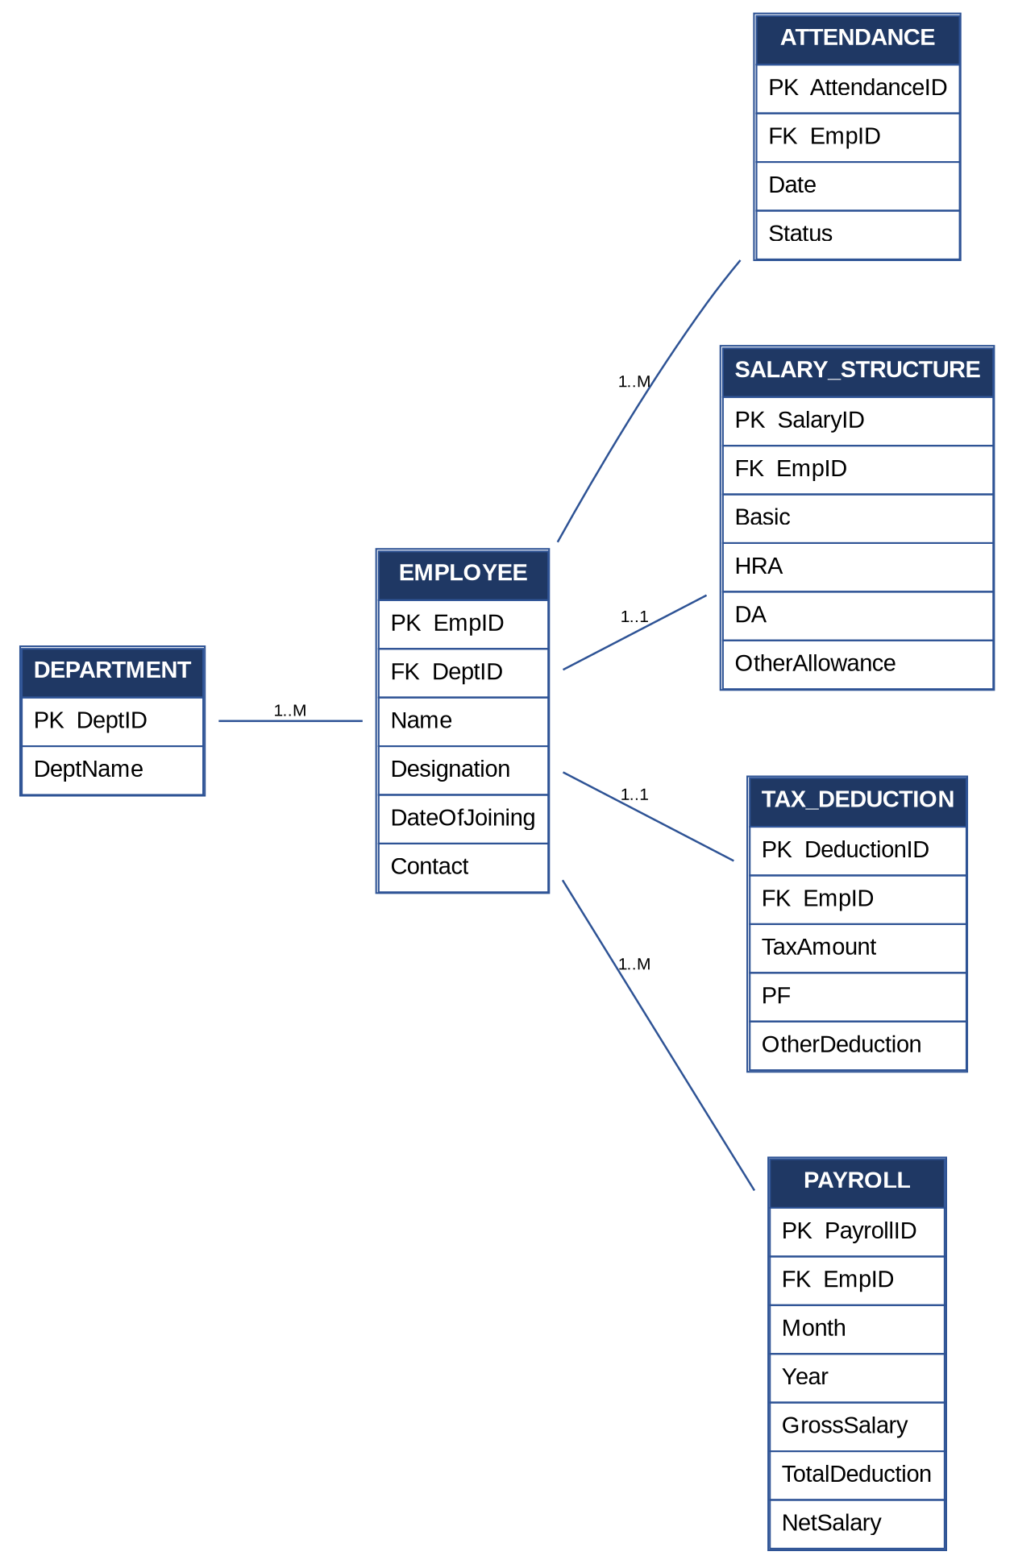

3. Database Connectivity using Python
import sqlite3

conn = sqlite3.connect("payroll.db")
cursor = conn.cursor()

cursor.execute("""
CREATE TABLE IF NOT EXISTS Department (
DeptID INTEGER PRIMARY KEY,
DeptName TEXT NOT NULL
)
""")

cursor.execute("""
CREATE TABLE IF NOT EXISTS Employee (
EmpID INTEGER PRIMARY KEY,
DeptID INTEGER,
Name TEXT NOT NULL,
Designation TEXT,
DateOfJoining TEXT,
Contact TEXT,
FOREIGN KEY (DeptID) REFERENCES Department(DeptID)
)
""")

cursor.execute("""
CREATE TABLE IF NOT EXISTS SalaryStructure (
SalaryID INTEGER PRIMARY KEY,
EmpID INTEGER,
Basic REAL,
HRA REAL,
DA REAL,
OtherAllowance REAL,
FOREIGN KEY (EmpID) REFERENCES Employee(EmpID)
)
""")

cursor.execute("""
CREATE TABLE IF NOT EXISTS Payroll (
PayrollID INTEGER PRIMARY KEY,
EmpID INTEGER,
Month TEXT,
Year INTEGER,
GrossSalary REAL,
TotalDeduction REAL,
NetSalary REAL,
FOREIGN KEY (EmpID) REFERENCES Employee(EmpID)
)
""")

conn.commit()

4. CRUD Operations
cursor.execute("INSERT INTO Department VALUES (201, 'Production')")
cursor.execute("INSERT INTO Department VALUES (202, 'Human Resources')")

cursor.execute("INSERT INTO Employee VALUES (301, 201, 'Karthik Subramani', 'Machine Operator', '2022-03-01', '9988776655')")
cursor.execute("INSERT INTO Employee VALUES (302, 202, 'Divya Shree', 'HR Executive', '2021-07-15', '9988776656')")

cursor.execute("INSERT INTO SalaryStructure VALUES (401, 301, 18000, 5000, 3000, 1000)")
cursor.execute("INSERT INTO SalaryStructure VALUES (402, 302, 25000, 7000, 4000, 1500)")

cursor.execute("INSERT INTO Payroll VALUES (501, 301, 'July', 2026, 27000, 2200, 24800)")

conn.commit()
print("Tables created and sample records inserted successfully.")

print("\n--- READ: All Employees ---")
cursor.execute("SELECT * FROM Employee")
for row in cursor.fetchall():
print(row)

print("\n--- READ: Salary Structure with Employee Names ---")
cursor.execute("""
SELECT E.EmpID, E.Name, S.Basic, S.HRA, S.DA, S.OtherAllowance
FROM SalaryStructure S
JOIN Employee E ON S.EmpID = E.EmpID
""")
for row in cursor.fetchall():
print(row)

cursor.execute("UPDATE SalaryStructure SET Basic = 20000 WHERE EmpID = 301")
conn.commit()
print("\n--- UPDATE: Basic salary of EmpID 301 updated to 20000 ---")

print("\n--- READ: Verify Update ---")
cursor.execute("SELECT EmpID, Basic FROM SalaryStructure WHERE EmpID = 301")
for row in cursor.fetchall():
print(row)

cursor.execute("DELETE FROM Payroll WHERE PayrollID = 501")
conn.commit()
print("\n--- DELETE: Payroll record 501 removed ---")

print("\n--- READ: Remaining Payroll Records ---")
cursor.execute("SELECT * FROM Payroll")
rows = cursor.fetchall()
if not rows:
print("No payroll records found.")
else:
for row in rows:
print(row)

conn.close()
print("\nDatabase connection closed.")

5. Terminal Output
PS C:\Users\Siddarth\QueryProcessing> python scenario8.py
Tables created and sample records inserted successfully.

--- READ: All Employees ---
(301, 201, 'Karthik Subramani', 'Machine Operator', '2022-03-01', '9988776655')
(302, 202, 'Divya Shree', 'HR Executive', '2021-07-15', '9988776656')

--- READ: Salary Structure with Employee Names ---
(301, 'Karthik Subramani', 18000.0, 5000.0, 3000.0, 1000.0)
(302, 'Divya Shree', 25000.0, 7000.0, 4000.0, 1500.0)

--- UPDATE: Basic salary of EmpID 301 updated to 20000 ---

--- READ: Verify Update ---
(301, 20000.0)

--- DELETE: Payroll record 501 removed ---

--- READ: Remaining Payroll Records ---
No payroll records found.

Database connection closed.
PS C:\Users\Siddarth\QueryProcessing>

